**BRAND PROMO**

**VIDEO**

**Presented by;**

**G.R.Dharshini**

**S.janani sri**

**M.sowmiya**

**A.shruthi**

**BRAND PROMO VIDEO**

**Introduction**

In digital marketing we are taking the brand promo video .By using the canva app we created the promo video for 60 seconds.The video was created for one specified brand.In this video we include the specifications, Quality, offers etc for this particular brand

So we are created the clothing brand it was " FASHIONICON ".It was the women's brand .

In this video we mentioned the fabric selection, colour and selection of sewing method and finial garment out put

Image

**Objectives**

It is the easy way reach to the customer.

Easily everyone can understand the product details and description.

The video was very short so everyone can watch easily

By this video we can analyse the wholes process for creating the garment

**Methodology**

First we selected the brand name

"**FASHION ICON"**

|

Designed the brand logo

|

Poster making

|

Promo video

|

Video Editing using canva

|

Channel creating

|

Upload in gitup.

Brand name:

We are created the brand that was fashion icon using the canva and it was the women clothing. And we are uploaded and joined in the video.

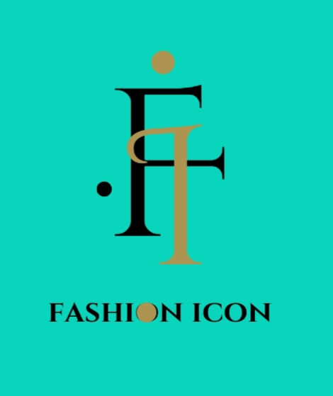

Poster making:

We are created the poster using canva. We used animated effects in the posters and we used different colors combinations for the poster.

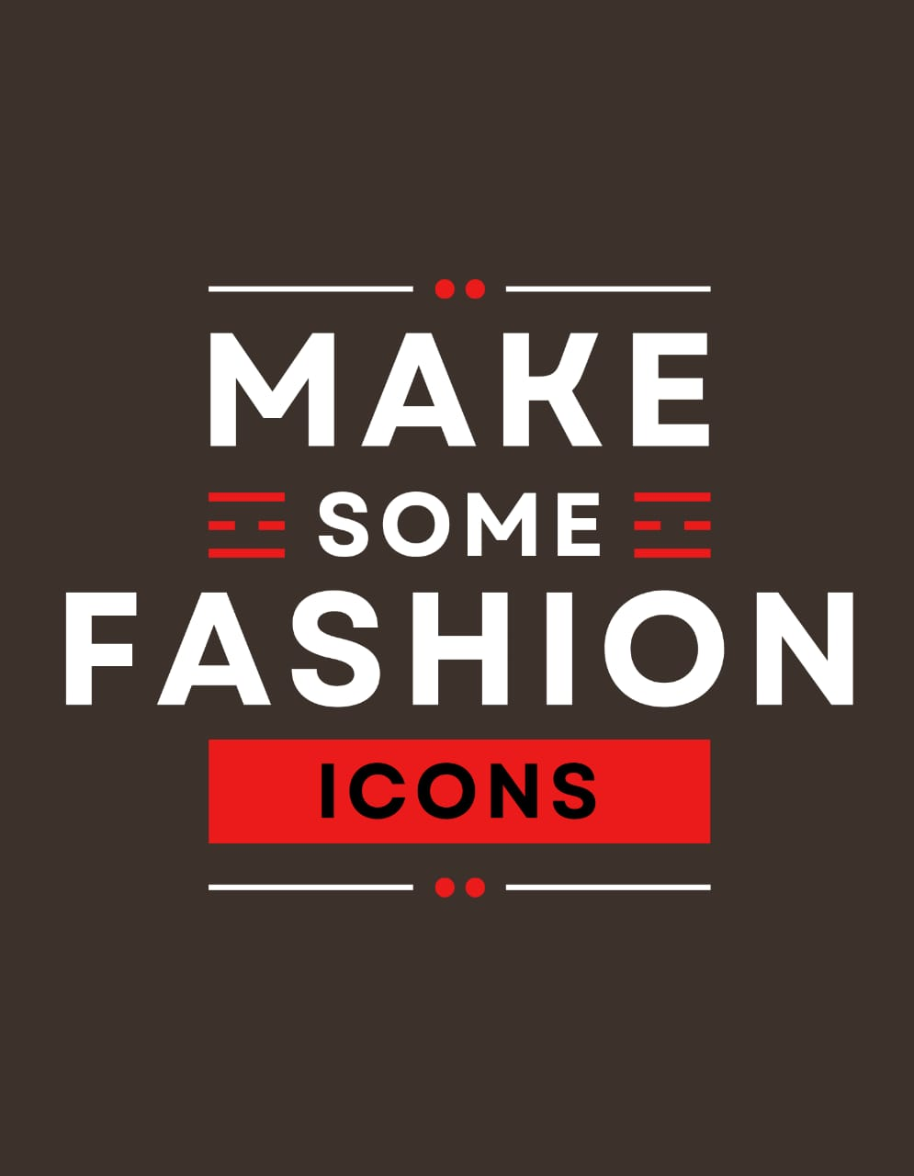

Promo video:

We created the promo video using canva . Using the category of the clothing . So we created the clothing brand. We are created 60sec promo video using canva.



Poster making:

We are used different types of poster for our brand posters. And we used canva. For making a posters and we used the clothing template for the poster making.

Video Editing :

We are created promo video using canva. And we choose the different template and different video for the this branding video. And we are chosen from fabrications , selection of fabrics, and we uploaded the sales of our products.

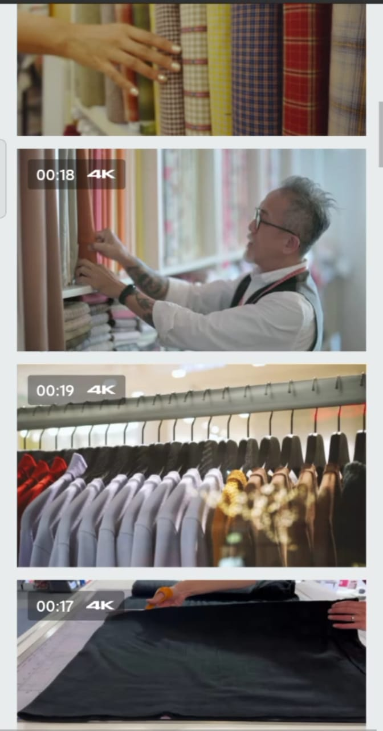

Channel creating in you tube:

We are created the you tube channel in the you tube the name of fashion icon brand . And we created the channel using the mail id. That was name of the fashionicon.

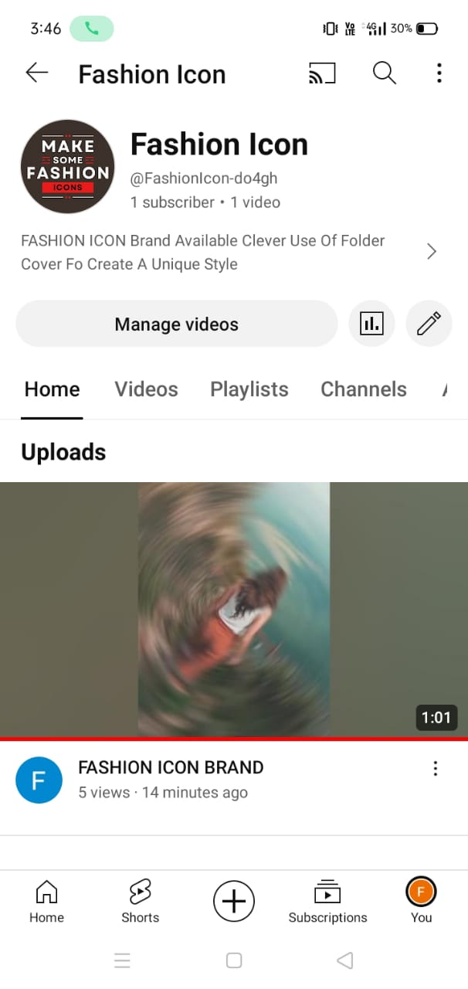

Upload the link in the gitup:

We are copy the link from the you tube channel and we have to pasted the link in the gitup website